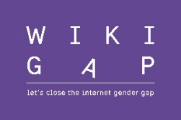

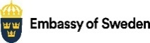 | 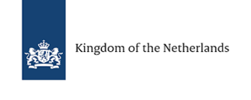 | 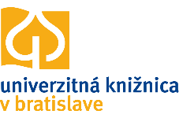 | 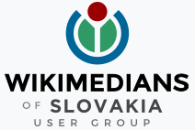 | 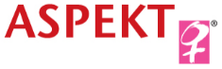

WikiGap – a joint effort in Slovakia to make the internet more gender-equal
On Saturday 7 May 2022, the Embassy of Sweden together with the Embassy of the Kingdom of the Netherlands, the Slovak organisation ASPEKT and Wikimedia Slovensko will highlight important women, female experts and role models from Slovakia by arranging a #WikiGap event. With this initiative, we want to broaden the content about women and increase the number of women represented on Wikipedia and contribute to making the internet more gender equal.
Wikipedia is the world’s largest online and user-generated encyclopaedia. Knowledge is power, and Wikipedia has the potential to colour our view of the world. However, there is great imbalance between men and women on the website, just like in society at large. Ninety per cent of those who add content to Wikipedia are men and there are four times as many articles about men as there are about women. The figures vary regionally, but no matter how you look at it, the picture is clear: the information about women is less extensive than that about men.
To contribute to a more accurate picture, the Swedish and Dutch Embassies, ASPEKT and Wikimedia Slovakia have therefore taken the initiative for this #WikiGap event on 7 May 2022. The event will be held in hybrid format where participants will gather at the University Library in Bratislava but also online to add more content to Wikipedia about important women, female experts and role models in various fields.
“When women's efforts are not visible, it directly affects our gender equality, our economy and our democracy. Concrete efforts are needed to address the imbalance that prevails, both in the real and in the digital world. The WikiGap event in Slovakia will be one small but important part of these efforts”, say the Ambassadors Annika Markovic (Sweden) and Gabriella Sancisi (The Netherlands).
This event is a part of the global #WikiGap campaign, launched in 2018. So far, #WikiGap editathons have been arranged in more than 60 countries, engaging more than 2 500 participants who have added or updated more than 50 000 Wikipedia articles in more than 30 different languages. The articles have reached more than 100 million views.
Join us, and let’s together close the internet gender gap!
For more information and to register, please check out the event landing page!
Contact: info.wien@gov.se

